Headquarters, Morell’s Division

Camp at Harrison’s near James River

Va July 10/62

My dear sir:

I am this moment in receipt of yours of the 8th.

I had a conversation with Lieut Col Rice, who now commands the 44th Regt, this morning about your son to use his promotion. Col. Rice said he was missing but was probably a prisoner. As soon as I can learn his fate I will inform you & be assured if I can do anything to promote his interests I will take great pleasure in it.

The Division formerly under command of Gen. Porter is now commanded by me. It suffered seriously during late battles.

Very truly,

Your friend

Geo. W. Morell

F. Walker, Esq.

[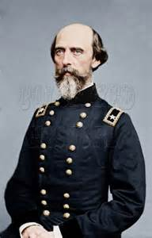](http://www.bing.com/images/search?q=george+w.+morell&view=detailv2&&&id=FB639E48B384C460733EB4E433DF1AFBB0909305&selectedIndex=0&ccid=Gq8mohyw&simid=607986311119571976&thid=JN.RgXQDO%2fcnQwdHEOQhkl5SA)

Major General George Webb Morell